Dr Kathleen Gray
Presentation:
E-health means participatory health: how social, mobile, wearable and ambient technologies are raising consumer expectations and supporting new social movements
Kathleen Gray is a senior researcher in the Health and Biomedical Informatics Centre at the University of Melbourne (www.healthinformatics.unimelb.edu.au). She coordinates the University’s postgraduate teaching in Health Information Technology and eHealth. She is active in several professional and industry associations in the field. She has Masters degrees in Library & Information Science and in Environmental Science, and a PhD in e-learning, and she is a Fellow of the Australasian College of Health Informatics. Her current research activities are in the areas of:
- Health sector change arising from new technologies
- Public participation in health through new technologies
- Educating health professionals to work with new technologies

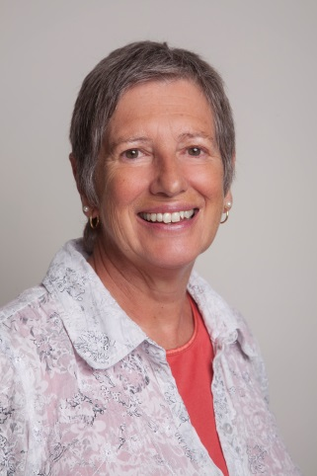

Dr Kathleen Gray
Health and Biomedical Informatics Centre, University of Melbourne
Phone 8344 8936 Mobile 0418 318 920
Email kgray@unimelb.edu.au
www.healthinformatics.unimelb.edu.au
Clara Ri
Presentation: “Tools 2 Talk”
Tools2Talk is an exciting app that allows you to create customised communication resources. It is easy to navigate and allows you to choose from a variety of templates to create communication aids such as activity schedules, choice making boards and community request cards. Tools2Talk has 2 symbol sets to choose images from, as well as the capacity to insert photos from your iPad camera roll. Your customised aids can to be emailed and printed out in minutes. Tools2Talk is the go-to app for quick and simple communication aid creation!
Clara Ri is a senior speech pathologist who has worked with people with disabilities for over 12 years. Clara has extensive experience working with children and young adults with complex communication needs who use Augmentative and Alternative Communication. Clara works at Scope’s Communication & Resource Centre in Box Hill, as the coordinator of the Non-Electronic Communication Aid Scheme (NECAS). She also provides training, and supports organisations around Victoria to become communication accessible.
Clara Ri
Speech Pathologist ,Scope’s Communication & Inclusion Resource Centre
P: 03 9843 2007 or 03 9843 2000
E-mail: cri@scopevic.org.au
www.scopevic.org.au

Veronica Lyons
Presentation: “Out and About App”
Veronica is the project manager for the Out & About project which include the Out & About – Accessing Your Community App and the Out & About Family Fun Day. In 2012 Veronica undertook a Diploma of Management at RMIT through Villa Maria and my project was the beginning of the Out & About App. The initial app development process took approximately 9 months, it was launched to iPhone at the first Out & About Family Fun Day event on December 1, 2013. In October 2014 the app was released to android and optimised for iPad and Tablets. We continue to expand the Out & About app and event to demonstrate the importance of 100% accessibility for all the community.
Veronica manages the development, implementation and administration of all fundraising and some marketing activities at Villa Maria, including the Direct Mail campaigns, donor relations, corporate partnerships, fundraising and community events.
Veronica Lyons, Community Engagement Manager, Villa Maria.
T: 9412 8407 E: veronica.lyons@villamaria.com.au

